DataOnDemand
DODApp service
Detailed Design Document

Author: Huang Li
Version: 0.1
Date: 2007-02-25

1 Introduction 5
1.1 Purpose 5
1.2 Definitions, Acronyms, and Abbreviations 5
1.3 References 5
1.4 Overview 5
1.4.1 Module 6
2 Static Class View 8
3 System Sequence View 9
3.1 Sequence Diagram 9
4 主要流程说明 11
4.1 Destination的创建流程图 11
4.2 DataOnDemand Initialization Logic 12
4.2.1 根据本地数据库中的Destination和Session对应关系重建DataStream： 12
4.2.2 与JMSdispatch的数据同步 12
4.3 Channel类型 13
4.3.1 LoaclFolder Channel 13
4.3.2 ShareFolder Channel 13
4.3.3 Message Channel 14
5 主要类的说明 18
5.1 DODAppServer 18
5.2 DODAppServiceImpl 18
5.3 DODPurchaseImpl 19
5.4 DODAppMainThread 20
5.5 PingThread 20
5.6 DODAppServer 21
5.7 DataPublisherImpl 21
5.8 DestinationImpl 23
5.9 ChannelPublishPointImpl 24
5.10 FolderChannelImpl 24
5.11 MessageChannelImpl 25
5.12 ActiveChannel 26
5.13 ActiveChannelMgr 27
5.14 ActiveSharedFolderChannel 27
5.15 ActiveLocalFolderChannel 28
5.16 ActiveMsgChannelBase 29
5.17 DODAppThread 29
5.18 ActiveMsgChannelThread 30
5.19 ActiveMsgChannel 30

Revision History

Version | Revise Date | Owner | Notes
0.1 | 2007-02-25 | Huang Li | 初稿

Introduction

Purpose
This document provides a detailed design of the project, intended to give a comprehensive understand on this project.

Definitions, Acronyms, and Abbreviations
DOD: Data on Demand
DODApp: Data on Demand Application
JMSDispatch: working as the client DODApp, fetching configuration/message from BackOffice’s JBOSS server, then invoke DODApp interface to deliver operations. It is a dll and integrated in DODApp.
DODStreamService: Data on Demand Stream Service, it is responsible for allocating and managing DODStream.
Business Router: This component is to find the right TianShan Application based on the request according to the configuration.
Agent Server: Admin-Side Application to interactive with DOD Agent
Weiwoo: The Session Management system
PHO: Path Help Object, plug-in of Weiwoo to evaluation and narrow the ContentStore and Stream to get out the lowest load and destination reachable Stream.
DOD ContentStore: the component to complete the data wrapping.

References
1、TianShan Arch Introduction （SE1- Andy）
2、StreamNow （SE1 - Andy）
3、DSA Detailed Design Document （SE2 - Andrew Zhang）
4、ITV Library 针对DOD的新需求 （CA - Jerry）

Overview
This document uses some design artifacts to describe the project on the coding-level, the final codes of this project should corresponding to this document.

Module
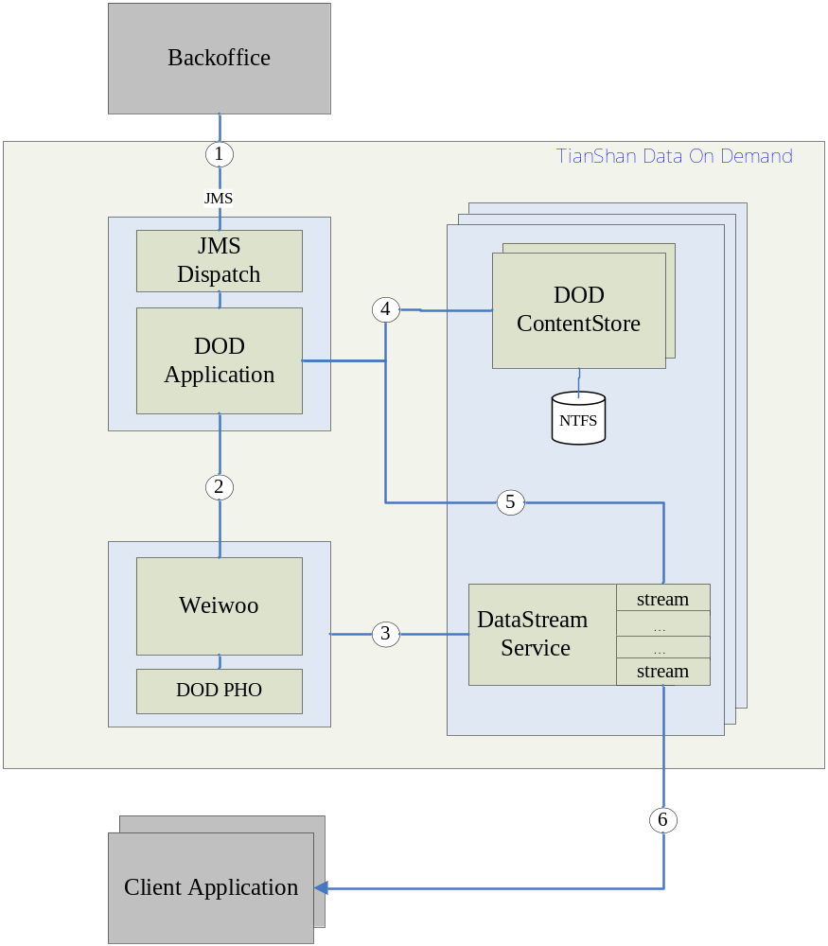
DODApp Service包括两个模块:
1. JMSDisPatch是一个动态链接库.它是用来向Agent Server请求PortConfigration信息的,并且解析从DOD Agent Server发过来的消息(包括PortConfigration, 数据更新, 消息增加).解析完后通知DODApp去处理相关的逻辑.
2. DODApp,它负责创建和管理所有的Destination和Channel.开始启动时它会通知JMSDispatch去向Agent Server请求PortConfigration信息,当JMSDispatch得到PortConfigration信息并解析完后会通知DODApp去创建所有的Destination和Channel, 并建立起关联关系,在创建Destination和Channel的同时,DODApp会通知Weiwoo创建相应的Stream. 当Destintion和Channel创建完后,DODApp会通知DataStream播流.
3.DODContentStore Service 负责将文件打包成Ts格式的流文件,打包完成后DODAppService会通知DataStream Service播流.

Static Class View
This section describes the primary classes and their static relationship.
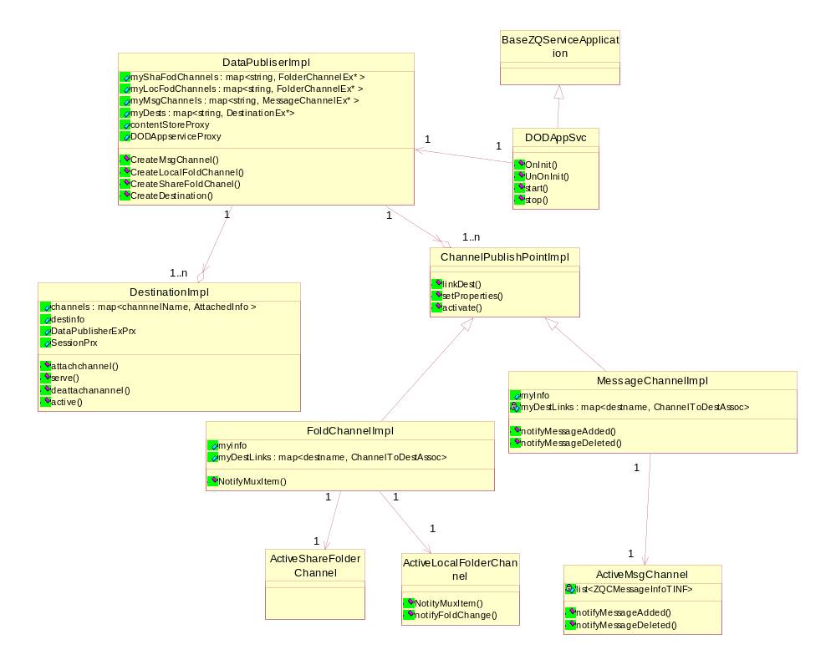

System Sequence View
This section explains the execution sequence or work flow of the system.

Sequence Diagram
Place the sequence among the classes here that the former section described.
DataOndemand init Sequence
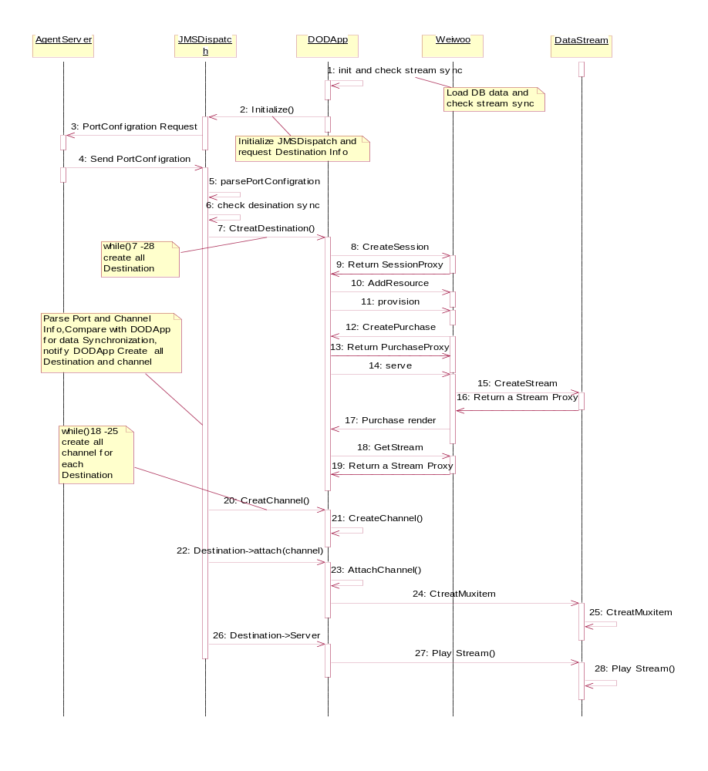
Message Updata sequence
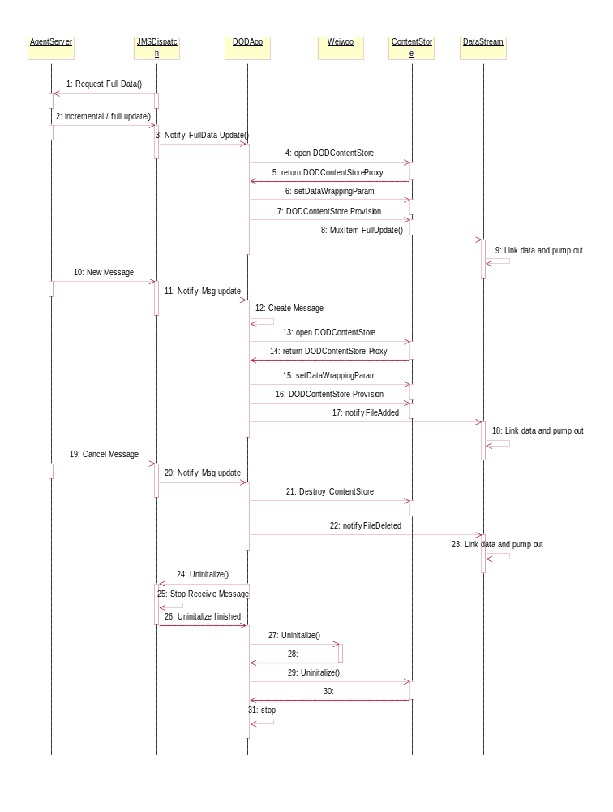

主要流程说明

Destination的创建流程图
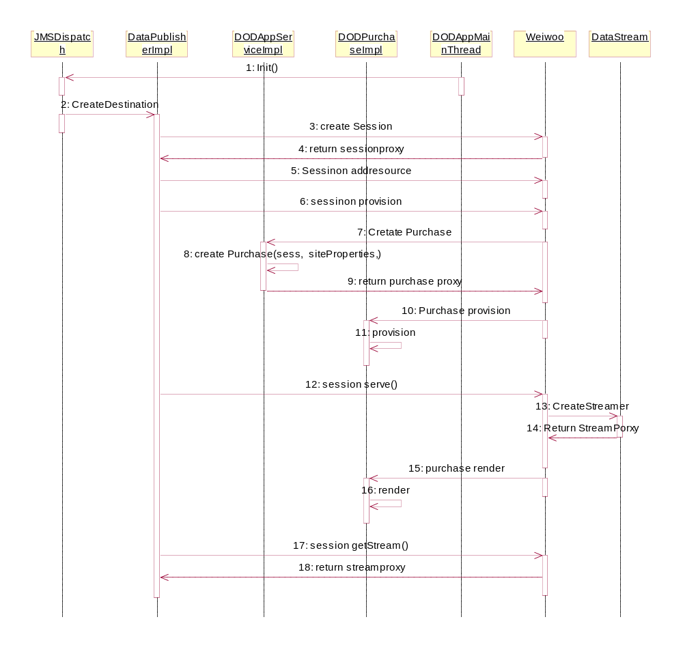
DataPublisherImpl. DODAppMainThread DODAppService DODPurchaseImpl为DODApp Service中的四个类.

DataOnDemand Initialization Logic
DODApp启动后首先加载本地数据库中的数据.根据Session重新建立起DataStream ,然后与JMSDispatch同步数据,具体过程如下:

根据本地数据库中的Destination和Session对应关系重建DataStream：
具体流程图如下:
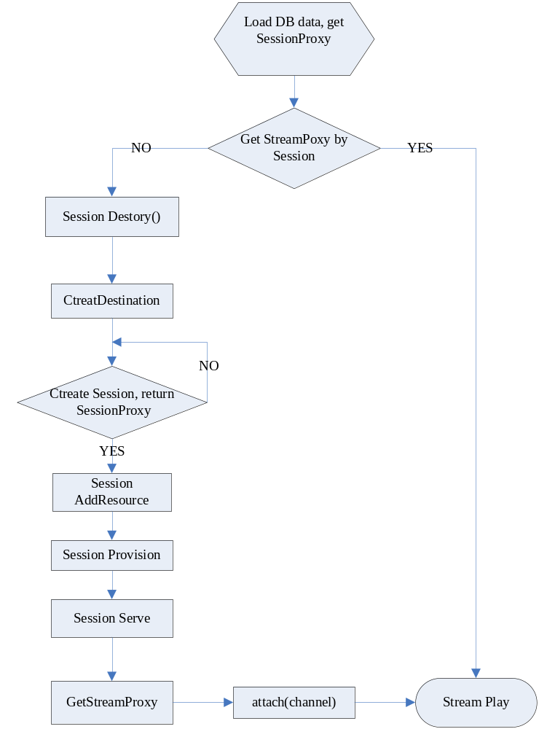

与JMSdispatch的数据同步
具体流程如下：
首先JMSDispatch 获得DODApp中所有的Destination信息,然后根据从Application Agent那里得到的PortConfigration信息根据每个Port Name逐个作比较,如果Port和Desination的数据不一致,则JMSDispatch通知DODApp Destory Destination. 全部比较完后, JMSDispatch会通知DODApp把Destinations列表中多余的Destination Destory. 这样就保证了DODApp与JMSDispatch中的数据一致了.

Channel类型
三种类型的Channel: LoaclFolder Channel 、ShareFolder Channel 、Message Channel。

LoaclFolder Channel
LocalFolder模式的Channel，在CreateChannel的时候会创建一个线程专门去检测文件夹的变化，一旦有变化，DODApp会通知ContentStore重新打包，打包完后再通知DataStream播流。

ShareFolder Channel
ShareFolder模式的Channel：Application Agent将数据准备好通知JMSDispatch，JMSDispatch 解析完后通知DODApp去处理数据。DODApp在本地有一个文件夹是专门用来存放数据的，它会把Application Agent发过来的临时路径里面的数据拷贝到自己的Cache Folder中，然后删除那个临时目录。整个流程如下图所示
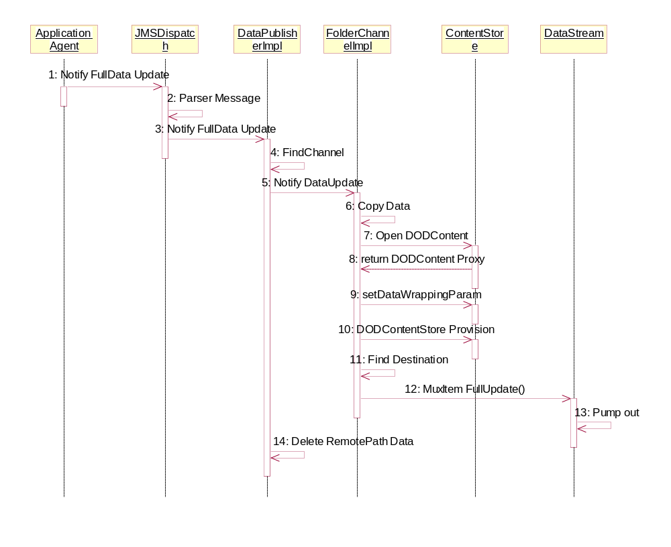
DODApp将数据拷贝到本地后，然后通知DODContent去打包，传给DODContent打包需要的数据。DODContent打包完后告诉DODApp打包好的文件的位置，

Message Channel
Message 模式的Channel：是通过TCP/IP的方式进行数据交换的。Application Agent发过来的消息本身中就含有消息的内容，JMSDispatch解析出消息内容后通知DODApp去处理。DODApp会在本地CacheFolder中创建一个Message文件，然后会通知ContentStore去打包，最后通知DataStream播流。整个流程如下图所示
Message Add：
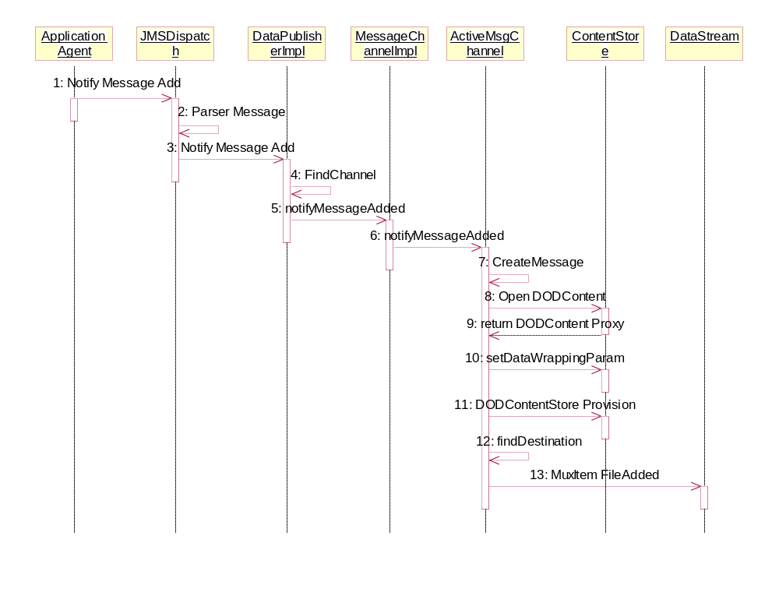
Message cancel：
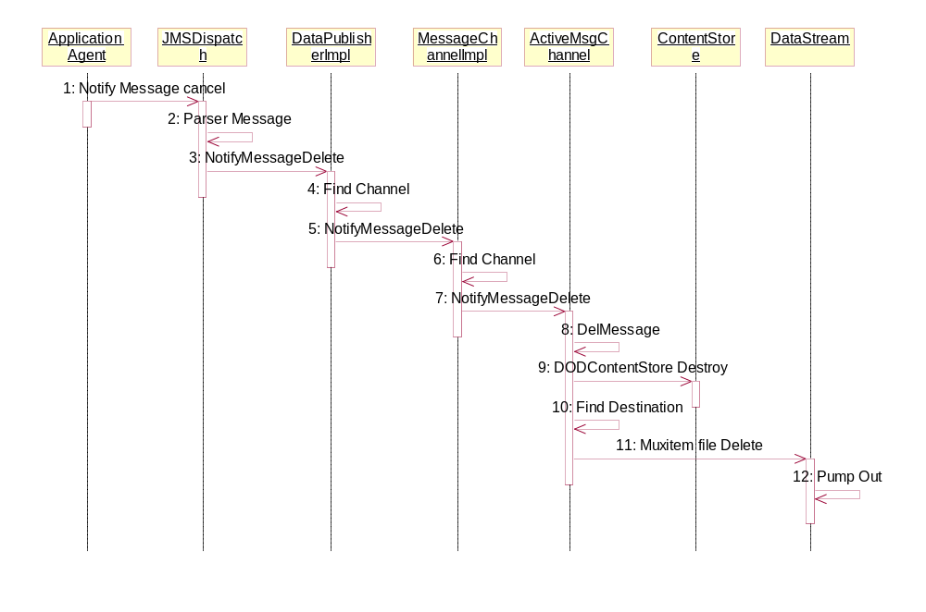

Message Channel内部处理流程
每个Message都有持续的时间，一旦这个Message过期，DODApp必须通知DataStream移除这个Message文件对应的Ts流。在ActiveMsgChannel类中有一个m_MessageList成员专门来维护所有的Message列表，在创建Channel的同时会有一个线程专门来检测这个Message列表，一旦Message过期就会从MessageList列表中清除这个Message，然后通知ConstentStore Destroy这个Message对应的DODContent文件，同时通知DataStream移除这个Message文件对应的Ts流重新Link，然后播流。
typedef struct Message_Info
{
// The message body was save into the file.
::std::string fileName;
//It denote a order number in the queue.
//bForever=TRUE,means= forever;else has duration
BOOL bForever;
//each message deleteTime;
long deleteTime;

// messageid and nDataType identify message
::std::string sMessageID;
int GroupId;
}ZQCMessageInfoTINF, *PZQCMessageInfoTINF;

打包参数：
::std::string name;
::Ice::Int subchannelCount;
::Ice::Int streamId;
::TianShanIce::IValues dataTypes;
::Ice::Int streamType;
::DataOnDemand::EncryptMode encrypt;
::Ice::Int tag;
发送参数：
::Ice::Int minBitRate;
::Ice::Int repeatTime;

LocalConfig file Format

<ConfResponse State="1" Format="2">

<ListOfNode>

<DCAPortConfiguration DataTypeWithInitial="17;18" QueueName="DOD_Queue_HP">

<ChannelList>

<Message Encrypted="1" StreamCount="0" StreamType="248" SendIndexTable="0" DataExchangeType="1" SendMsgExpiredTime="0" StreamID="141" Tag="MSG" MessageCode="1911" DataType="24;29" SendMsgDataType="0" ChannelType="0" QueueName="queue_TICP"/>

<TicketListMessage Encrypted="1" StreamCount="0" StreamType="247" SendIndexTable="0" DataExchangeType="1" SendMsgExpiredTime="0" StreamID="151" Tag="TMS" MessageCode="1331" DataType="27;28" SendMsgDataType="0" ChannelType="0" QueueName="queue_OTE"/>

<Portal StreamID="121" StreamType="144" StreamCount="5" DataType="11" DataExchangeType="2" SendMsgDataType="0" MessageCode="1411" SendIndexTable="1" Tag="NAV" Encrypted="1" ChannelType="1" SendMsgExpiredTime="0" QueueName="\\10.50.12.4\TestWarp\"/>

<Nav Encrypted="2" StreamCount="0" StreamType="248" SendIndexTable="1" DataExchangeType="0" SendMsgExpiredTime="0" StreamID="142" Tag="MSG" MessageCode="1911" DataType="11" SendMsgDataType="0" ChannelType="0" QueueName="queue_TICP"/>

</ChannelList>

<Port>

<TELMSG PMTPID="288" GroupID="0" TotalRate="820000">

<Channel>

<Message RepeatTime="1500" ChannelRate="100000" />

<TicketListMessage RepeatTime="1500" ChannelRate="100000" />

<Portal RepeatTime="0" ChannelRate="400000"/>

<Nav RepeatTime="1500" ChannelRate="100000" />

</Channel>

<IPPort>

<CASA1 SendType="2" IPAddress="233.0.0.2" IPPort="10010"/>

</IPPort>

</TELMSG>
<Test PMTPID="289" GroupID="3" TotalRate="820000">

<Channel>

<Nav RepeatTime="1500" ChannelRate="100000" />

<TicketListMessage RepeatTime="15000" ChannelRate="100000" />

<Portal RepeatTime="0" ChannelRate="400000"/>

</Channel>

<IPPort>

<CASA11 SendType="1" IPAddress="192.168.81.101" IPPort="808"/>

<CASA22 SendType="1" IPAddress="192.168.81.101" IPPort="809"/>

<CASA33 SendType="1" IPAddress="192.168.81.101" IPPort="810"/>

</IPPort>

</Test>
<Test1 PMTPID="290" GroupID="3" TotalRate="820000">

<Channel>

<Message RepeatTime="1500" ChannelRate="100000" />

</Channel>

<IPPort>

<CASA11 SendType="1" IPAddress="192.168.81.101" IPPort="811"/>

</IPPort>

</Test1>

</Port>

<DODQueue>

<Queue1 Priority="P1" Name="DOD_Queue_HP"/>

<Queue2 Priority="P2" Name="queue_DOD"/>

</DODQueue>

</DCAPortConfiguration>

</ListOfNode>

</ConfResponse>

主要类的说明

DODAppServer
这个类是从Ice::Application派生的.它的作用如下:
- 初始化ICE.
- 连接Weiwoo Service
- 连接ContentStore Service
- 负责DODApp Service与Weiwoo Service之间的数据同步
- 初始化 JMSDispatch.
Attribute list
NAME | Type | DESCRIPTION
_appSvr | DODAppServer * | Application对象的指针

- Operation List
NAME | DESCRIPTION
int run() | Application运行函数,连接Weiwoo 和 ContentStore Service
bool initDispatch() | 初始化JMSDispatch.获得Destination和Channel需要的信息

DODAppServiceImpl
这个类是DODAppService的实现类, DODAppService是从TianShanIce::Application::AppService继承下来的, represents the basic entry points to a business logic in TianShan, 用来管理所有的Session和Purchase信息
Attribute list
NAME | Type | DESCRIPTION

- Operation List
NAME | DESCRIPTION
::TianShanIce::Application::PurchasePrx createPurchase() | create a purchase,invoked by Weiwoo BusinessRouter after it selected this application service.

DODPurchaseImpl
这个类是DODPurchase的实现类, DODPurchase是从TianShanIce::Application::Purchase, brief represents an order or purchase in the business logic reflect to TianShan session
Attribute list
NAME | Type | DESCRIPTION

- Operation List
NAME | DESCRIPTION
::TianShanIce::Weiwoo::SessionPrx getSession() | list all the Weiwoo session instances bound on this purchase
void render() | render this purchase onto a stream instance
void provision() | provision the purchase
void detach() | detach a session from this purchase transaction. this will be called when a Weiwoo::Session is end
void bookmark() | Bookmark the current rendering position

DODAppMainThread
这个类是从NativeThread派生的
- Attribute list
NAME | Type | DESCRIPTION
_appSvr | DODAppServer * | Application对象的指针

- Operation List
NAME | DESCRIPTION
bool init() | 线程初始化
int run() | 线程运行函数,初始化appSvr
void final() | 线程终止

PingThread
PingThread是从DODAppThread继承下来的,它的主要作用就是保持与DataStream Service之间的连接,当连接断开时,会负责尝试重新连接.并在重新连接后同步DODApp Service与DataStream Service的数据.
NAME | DESCRIPTION
int run() | 线程运行函数,负责与DataStream服务器连接, 一旦失去连接会尝试Ping直到Ping通为止

DODAppServer
这个类是从BaseZQServiceApplication派生的, 使得这个application成为标准的ZQ Service Application. 在这个类中必须实现下面这几个虚函数:
- Operation List
NAME | DESCRIPTION
HRESULT OnInit() | 创建一个DODAppMainThread对象
HRESULT OnUnInit() | 删除DODAppMainThread对象
HRESULT OnStart() | 调用DODAppMainThread->start()启动线程函数,初始化DODAppServer对象
HRESULT OnStop() | 调用DODAppMainThread->stop(),通知JMSDispatch停止接收消息, 销毁创建的线程.

DataPublisherImpl
这个类是DataPublisterEx接口的实现.它是DODApp与JMSDispatch之间的接口.
主要负责处理从JMSDispatch发过来的消息.
- Attribute list
NAME | Type | DESCRIPTION
_dataStreamSvc | DataStreamServicePrx | DataStream的代理,
_strmSvcEndPoint | std::string | DataStream的EndPoints
_dodAppService | DODAppServicePtr | DODAppServiceImpl的代理
_sessionmanager | SessionManagerPtr | SessionManager的代理
_ic | Ice::CommunicatorPtr | ICE Communicatorr 的Handle
- Operation List
NAME | DESCRIPTION
FolderChannelPrx  createLocalFolderChannel() | JMSDispatch调用, 创建LocalFolder类型的Channel
FolderChannelPrx createShareFolderChannel() | JMSDispatch调用, 创建ShareFolder类型的Channel
MessageChannelPrx  createMsgChannel() | JMSDispatch调用, 创建Message类型的Channel
DestinationPrx  createDestination() | JMSDispatch调用, 创建Destination,在其内部通知DataStream创建Stream.
void notifyFolderFullUpdate() | JMSDispatch调用,通知ShareFolder类型的Channel更新
void notifyFolderPartlyUpdate() | JMSDispatch调用,通知ShareFolder类型的Channel更新
void notifyFolderDeleted() | JMSDispatch调用,通知ShareFolder类型的Channel更新
void notifyFileAdded() | JMSDispatch调用,通知,ShareFolder类型的Channel更新
void notifyFileModified() | JMSDispatch调用,调用,通知ShareFolder类型的Channel更新
void notifyFileDeleted() | JMSDispatch调用,通知ShareFolder类型的Channel更新
void notifyMessageAdded() | JMSDispatch调用,通知Message类型的Channel有新的消息
notifyMessageDeleted() | JMSDispatch调用,通知Message类型的Channel有消息过期
void reconnect() | 当DataStream与DODApp之间的连接断开重新连接后,负责数据同步
bool checkSync() | DODApp启动时,负责与DataStream之间的数据同步

DestinationImpl
这个类是DestinationEx接口的实现,一个Destination对应一个Stream.
- Attribute list
NAME | Type | DESCRIPTION

- Operation List
NAME | DESCRIPTION
::std::string getName() | 获得Destination的名称
DestState getState() | 获得Destination的状态
void attachChannel() | 将Destination与Channel关联,并通知DataStream创建MuxItem
void detachChannel( | 取消Destination与Channle的关联
DestInfo getInfo() | 获得Destination的信息
void serve() | 通知DataStream播流
void stop() | 通知DataStream停止播流
void pause() | 通知DataStream暂停播流(未实现)

ChannelPublishPointImpl
这个类是ChannelPublishPointEx接口的实现,它是所有Channel的父类.包含所有Channel的基本的操作.
- Attribute list
NAME | Type | DESCRIPTION

- Operation List
NAME | DESCRIPTION
::std::string getName() | 获得Channel名称
ChannelType getType() | 获得Channel的类型
ChannelInfo getInfo() | 获得Channel的信息
void linkDest() | 将Channel与Destination关联
::TianShanIce::Properties getProperties() | 得到Channel的附加属性
void setProperties() | 设置Channel的附加属性

FolderChannelImpl
这个类是FolderChannelEx接口的实现, 它表示ShareFold和LocalFold类型的Channel.
- Attribute list
NAME | Type | DESCRIPTION
myInfo | ChannelInfo | Channel的信息
myDestLinks | DestLinks | 与Channle关联的Destiantion信息
myParent | DataPublisherEx* | DataPublisherEx的代理
myProps | TianShanIce::Properties | Channel的附加属性
myType | ChannelType | Channel的类型

- Operation List
NAME | DESCRIPTION
void notifyFullUpdate() | 当UpdataMode = 0或6时
void notifyPartlyUpdate() | 当UpdataMode = 1时
void notifyFolderDeleted() | 当UpdataMode = 2时
void notifyFileDeleted() | 当UpdataMode = 3时
void notifyFileModified() | 当UpdataMode = 4时
void notifyFileAdded() | 当UpdataMode = 5时
bool NotityMuxItem() | 通知ContentStore 打包 Link, 完后成通知DataStream Pump out

MessageChannelImpl
这个类是MessageChannelEx接口的实现,它表示Message类型的Channel.
- Attribute list
NAME | Type | DESCRIPTION
myInfo | ChannelInfo | Channel信息
myDestLinks | DestLinks | 与Channle关联的Destiantion信息
myParent | DataPublisherEx* | DataPublisherEx的代理
myProps | TianShanIce::Properties | Channel的附加属性
myType | ChannelType | Channel的类型

- Operation List
NAME | DESCRIPTION
void notifyMessageAdded() | Message增加,通知ActiveMsgChannel对象创建新的Message
void notifyMessageDeleted() | Message过期删除, 通知ActiveMsgChannel对象删除对应的Message

ActiveChannel
- Attribute list
NAME | Type | DESCRIPTION

- Operation List
NAME | DESCRIPTION
bool init()
void uninit()

ActiveChannelMgr
管理所有的Channel的对应关系,一个FolderChannelImpl对象对应一个ActiveSharedFolderChannel对象或者ActiveLocalFolderChannel对象; 一个MessageChannelImpl对象对应一个ActiveMsgChannel对象.

- Attribute list
NAME | Type | DESCRIPTION
_activeChannels | ActiveChannelMap | Channel 名称与 ActiveChannel *的对应关系

- Operation List
NAME | DESCRIPTION
ActiveChannel* create() | 创建一个对应关系
bool remove() | 移除某个Channel的对应关系
ActiveChannel* get() | 根据名称获得ActiveChannel*

ActiveSharedFolderChannel
这个类是与FolderChannelImpl对象关联的类. 是从ActiveChannel类继承下来的.
- Attribute list
NAME | Type | DESCRIPTION

- Operation List
NAME | DESCRIPTION

ActiveLocalFolderChannel
这个类是与FolderChannel关联的类. 是从ActiveChannel和DirConsumer继承下来的.当Channel是LocalFolder类型时,在DODApp Service中会创建一个线程去检测目录的变化,一旦目录发生变化,就会通知ContentStore重新打包数据,打包完后通知DataStream播流
- Attribute list
NAME | Type | DESCRIPTION

- Operation List
NAME | DESCRIPTION
Virtual bool NotityMuxItem() | 通知ContentStore 打包 Link, 完后成通知DataStream Pump out
bool processAdd() | 目录改变,文件增加,调用NotityMuxItem()
bool processDelete() | 目录改变,文件删除,调用NotityMuxItem()
bool processModify() | 目录改变,文件修改,调用NotityMuxItem()
bool processRenameOld() | 目录改变,重命名前旧的文件, 调用NotityMuxItem()
bool processRenameNew() | 目录改变,重命名后的文件, 调用NotityMuxItem()

ActiveMsgChannelBase
- Attribute list
NAME | Type | DESCRIPTION

- Operation List
NAME | DESCRIPTION
bool init()
activeChannelInit()

DODAppThread
DODAppThread是从NativeThread继承下来的线程类.
- Attribute list
NAME | Type | DESCRIPTION

- Operation List
NAME | DESCRIPTION
void stop() | 停止线程运行

ActiveMsgChannelThread

ActiveMsgChannelThread是从DODAppThread继续下来.
- Attribute list
NAME | Type | DESCRIPTION

- Operation List
NAME | DESCRIPTION
init() | 初始化线程

ActiveMsgChannel
ActiveMsgChannel是从ActiveMsgBaseChannel和ActiveChannelThread继续下来的,它与MessageChannelImpl类相关联.每个MessageChannel中的消息都有一个过期时间,这个线程就是检测消息是否过期,如果过期就将其删掉,然后通知DataStream重新打包播流.
- Attribute list
NAME | Type | DESCRIPTION
m_MessageList; | zqMessageList | Message 队列,按照过期时间排序
m_bStop; | bool | 是否停止线程

- Operation List
NAME | DESCRIPTION
void stop() | 停止线程运行
notifyMessageAdded() | Message增加,创建一个新的Message 文件,并将Message的相关信息加入到m_MessageList中,通知DataStream重新打包播流
notifyMessageDeleted() | Message过期,在m_MessageList根据MessageID找出过期的所有消息并删除对应文件并在MessageList移除
int run() | 线程运行函数
LoadMsgData() | 当DODApp重启后,加载先前的Channel中没有过期的消息
NotityMsgMuxItemAdd() | 通知ContentStore 打包文件,完成后通知DataStream Link and pump out
NotityMsgMuxItemDel() | Destory ContentStore ,并通知DataStream重新Link and pump out

